SSDT Installation fro VS2015

1 stop all sql services.

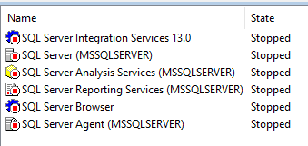

2 Mount SSDT setup from image disk.

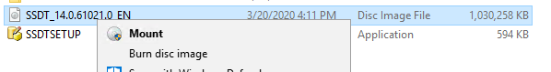

3 Open Mounted Drive



4 Right Click on SSDT Setup file and run as admin

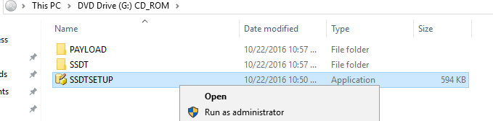

5 Click Yes

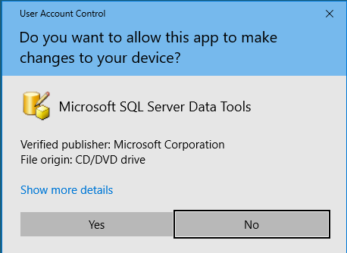

6 Choose for which features want to install ssdt and click next.

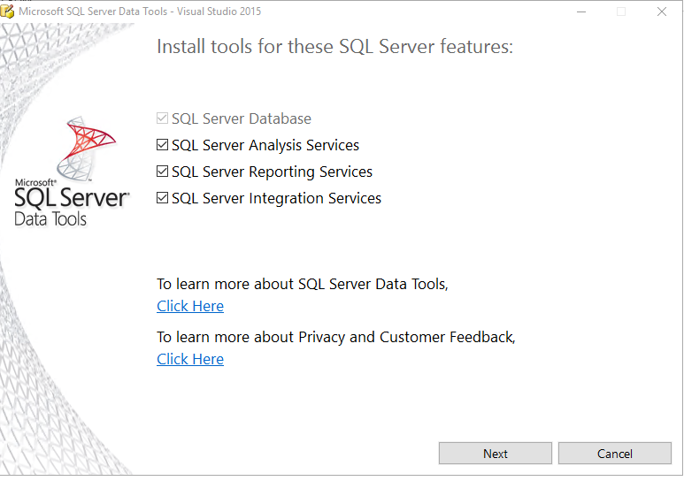

7 accept license and click on install

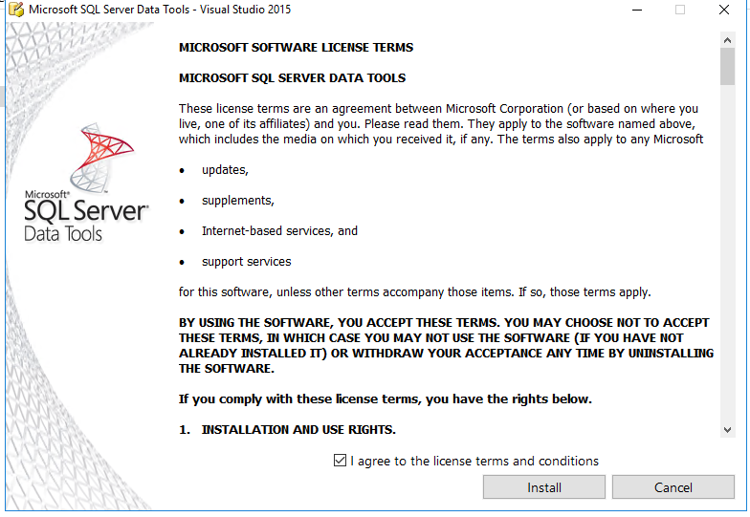

8 Installation is in process

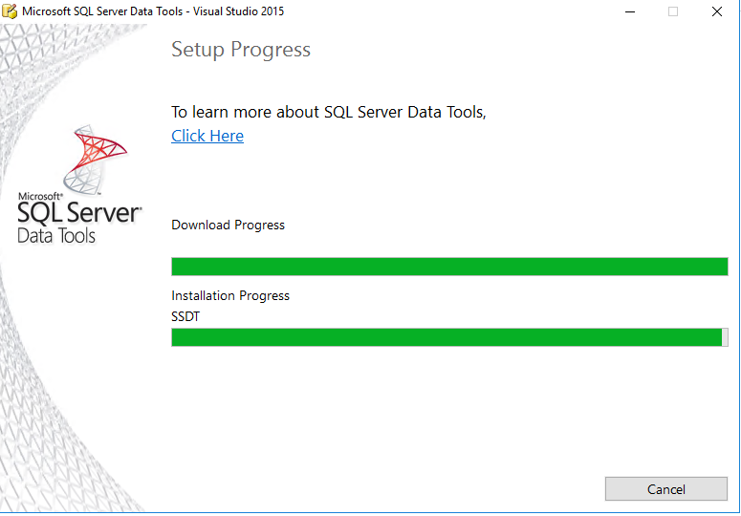

9 Installation Completes

